Robot framework:
- It is a generic test automation framework for acceptance testing.
- Done by the customers or users.
- Acceptance test-driven development(ATDD).
- It utilizes the keyword-driven testing approach.
- Provides test libraries implemented either with Python or Java, and users can create new higher level keywords from existing ones using the same syntax that is used for creating test cases.
- Not much programming is required.
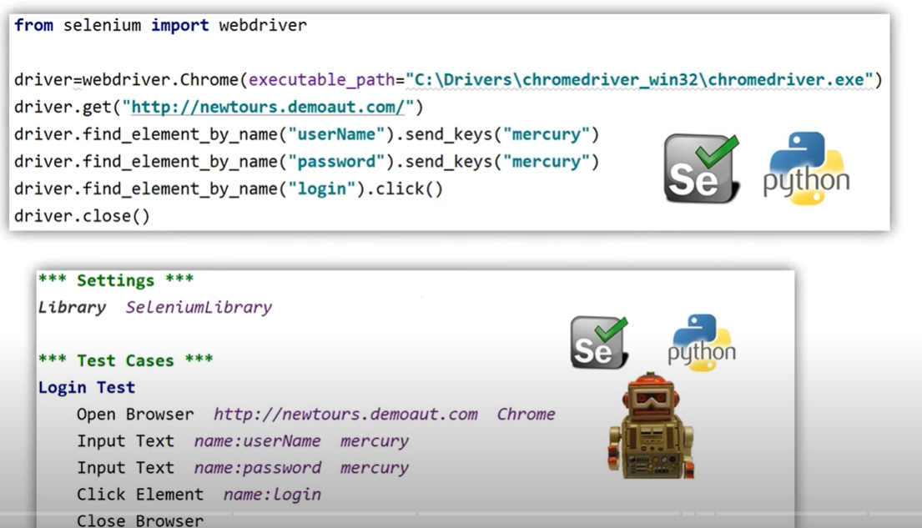

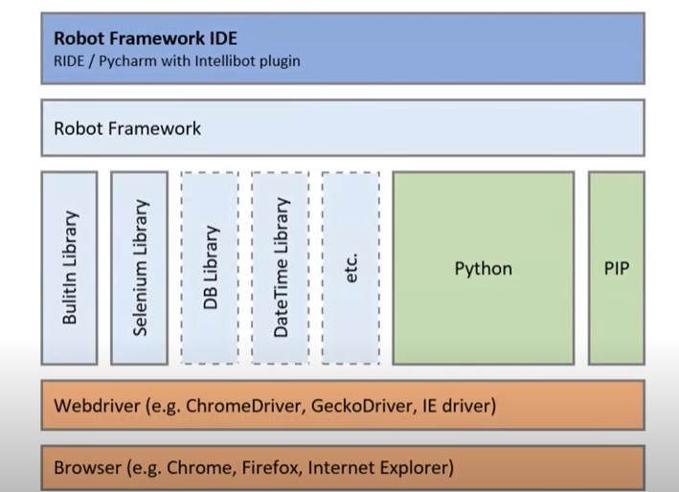

Setup:

- Python Installation
- Install Pycharm IDE
- Install selenium: pip install selenium
- Install robot framework: pip install robotframework /pip show robotframework
  - Pip install –upgrade robotframework
  - Pip install robotframework==2.9.2
  - Pip uninstall robotframework
  - Pip list
  - Pip check robotframework
- Install robot framework selenium library
  - Pip install robotframework-seleniumlibrary

Pycharm Project:
- Required packages
  - Selenium
  - Robotframework
  - Robotframework-seleniumlibrary
- Need to install plugins – IntelliBot and IntelliBot @SeleniumLibrary Patched

- Project Folder Structure
  - Selenium
  - Robot framework
  - Robotframework – seleniumlibrary
Example: https://demo.nopcommerce.com/
Execute command: pip install robotframework-browser
https://robotframework.org/SeleniumLibrary/SeleniumLibrary.html
- File Extensions
- Multiple sections in Robot file
- Writing test case
- Report

Working with Web Elements:
- Text Box/Input Box -> Inputbox.robot
- Visibility status
- Enabled status
- Provide value
- Clearing value
- Verifying title of the page

How to select Radio Buttons & Check Boxes: Radiobuttons.robot
Working with Drop Down and List Box: Dropdown.robot, Listbox.robot
Waits & Timeouts:
- Selenium Speed : Seleniumspeed.robot
- Selenium Timeout: seleniumtimeout.robot
- Implicit wait: Implicitwait.robot
- Sleep
Handle Alerts & Frames:
- How to handle Alerts: alerts.robot
- How to handle Frames: Frames.robot
How to close Single and Multiple Browsers:Closeall.robot
How to handle Tabbed Windows and Browser windows:Tabbedwindows.robot, Switchtomultiplebrowsers.robot
Browser related keywords(Navigational keywords):Navigationalkeywords.robot
- Go To
- Go Back
- Get Location
How to Capture Element & Full Page Screenshot: Capturescreen.robot
How to perform Mouse operations: Mouseoperations.robot
- Right click
- Double click
- Drag & Drop
User defined keywords: Userkeywords.robot
- User defined keywords without arguments
- User defined keywords with arguments
- User defined keywords with arguments and return value
Scrolling page using Javascript Executor: Scrollingpage.robot
- Scrolling page till it reach a pixel number
- Scrolling page till find element on page
- Scroll page till the bottom
For loop in Robot Framework: forloopdemo.robot
How to count & extract link texts: Getalllinks.robot
- Count number of links on web page
- Extract all the links from page
Working with HTML Table: Tabledemo.robot
- Count number of rows in a table
- Count number of columns in a table
- Get data from table
- Validations on table
Data Driven Testing Using Script: DDT1.robot and DDT2_Excel.robot
- Specify the test data in the script
- Read test data from excel file
Need robotframework-datadriver
Install: pip install pandas openpyxl
pip install -U robotframework-datadriver[XLS]
install pandas and openpyxl in settings
Setup and TearDown: SetupandTeardown.robot
- Test Setup – will run before every test case
- Test Teardown - will run after every test case
- Suite Setup – will run before Test Suite
- Suite Teardown - will run after Test Suite
Test Suite
- Test case1
- Test case2
Grouping Test using Tags: Tagging.robot
robot --include=sanity Testcases/Tagging.robot
robot --include=regression Testcases/Tagging.robot
multiple categories:
robot -i sanity -i regression Testcases/Tagging.robot
exclude:
robot -e regression Testcases/Tagging.robot
robot -e sanity Testcases/Tagging.robot
robot -e sanity -i regression Testcases/Tagging.robot
Parallel Test Execution in Robot Framework: ParallelTests.robot
- How to run Test Suites
- How to run Tests parallely using robotframework-pabot
- How to save results in Results folder
- How to run Tests using Single Windows Bat File

Using Folder:

Command to sequential execution of test cases: robot ParallelTests\

Using Regular expressions:

Regular expression: robot ParallelTests\Reg*.robot (starting with reg word files)
To execute all test cases: robot ParallelTests\*.robot

To execute test cases in parallely:
Pre-requisite: robotframework-pabot
Pabot is a parallel executor for the Robot Framework that runs test suites or test cases concurrently to reduce execution time.
Install above plugin in project -> settings -> python Interpreter
Command: pabot --processes 2 --outputdir Results ParallelTests\*.robot

Headless Browser Testing in RobotFramework:
- headlesschrome
- headlessfirefox

POM Pattern in Robot Framework: Resource/login_resources.robot
- Design pattern
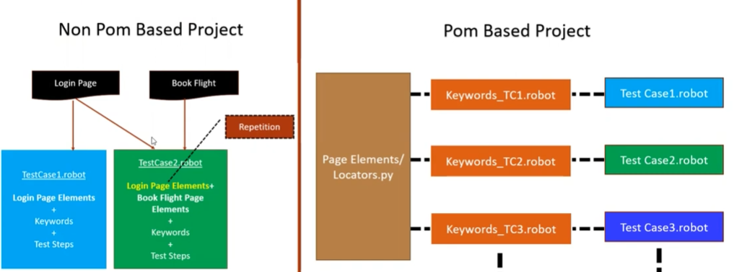

RobotFramework with Jenkins:
Jenkins: Jenkins is a self-contained, open source automation server which can be used to automate all sorts of tasks related to building, testing, and delivering or deploying software.
Download: jekins.war and run the command : java -jar Jenkins.war
Open in the browser: localhost:8080 or 127.0.0.1:8080
- How to create job in Jenkins
- How to add robot framework plugin in Jenkins
- How to configure robot framework tests in Jenkins
- Show html reports on Jenkins
- Run and validate
Steps:
- Download Jenkins
- Start Jenkins
- Add robot framework plugin in Jenkins
- Create job to run robot framework

General-> Advanced -> Use custom workspace
C:\Users\sekumarp\PycharmProjects\Robotproject\Testcases

Build Steps -> Execute Windows Batch command ->
cd C:\Users\sekumarp\PycharmProjects\Robotproject\Testcases
robot -d Results Capturescreen.robot Frames.robot

Post Build Actions:
Directory of Robot output:
Results

Search: jenkins content security policy
Goto Unset the header: System.setProperty("hudson.model.DirectoryBrowserSupport.CSP", "")
Manage Jenkins: search for script console and update the code and check.

